CANNINGTON PARISH COUNCIL

Notice of Vacancy in office Parish Councillor
(Two Vacancies)

Notice is hereby given that, due to resignation, two vacancies have arisen in the office of Parish Councillor for Cannington Parish Council.

If within 14 working days after the date of this notice a request for an election to fill the vacancies is made in writing to the Returning Officer at Somerset Council. Chief Executive, Electoral Services, Somerset Council, County Hall, The Crescent, Taunton, Somerset, TA1 4DY. This will be signed by ten local government electors for the Parish of Cannington, an election will be held to fill the vacancies.

If no such request is made, the vacancies will be filled by Cannington Parish Council by co-option.

* In computing any period of time for this purpose, a Saturday, Sunday, day of the Christmas break, day of the Easter break or a bank holiday or day appointed for public thanksgiving or mourning must be disregarded.
Write to Rebecca Gaylor

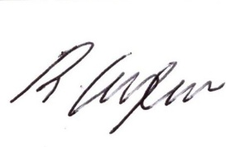
Clerk of the Parish Council 15th January 2026

