Appendix 3
CANNINGTON PARISH COUNCIL

MEMORIAL APPLICATION FORM

This application is to be completed for work proposed to be carried out in relation with a memorial as per the Cemetery Rules and Regulations (Item 6) with effect from 1.6.24.

No works shall be undertaken until written permission is granted by Cannington Parish Council who will not be responsible for any costs incurred for works to a memorial that was not approved.

SECTION 1: Applicant (s) to complete

Name of Deceased:
Date of Burial (if known): |  | Plot No:
To complete only where a Grant of Exclusive Right of Burial (ERB) exists (note ERBs were introduced 1.6.24).  If an ERB does NOT exist, please just complete Applicant 1 details below | Where an ERB exists, please provide the Registered owner(s) of the Grant of ERB (named on the deed of grant):  1.  2.  3. | Please provide the ERB Grant No:
Applicant 1:  Name:  Address of Applicant:  Tel No:  Email: | Applicant 2 (If applicable re ERB): | Applicant 3 (if applicable re ERB):
Please see notes for Memorial Mason overleaf
- I/we have read the current Cemetery Regulations governing Cannington Cemetery (item 6 dated 1.6.24)
- I/we understand that I/we will be responsible for the costs of erecting and maintaining the memorial
- I/we understand that the memorial remains my property and as the registered owner(s) I am responsible for keeping the memorial in good repair at all times to meet with current and future Health and Safety Regulations that may be applied.
- If the memorial is found to be in an unsafe condition, at any time, I/we accept that the memorial will be laid flat/removed and that I/we will be responsible for the cost of removal and renovation/repair cost if I choose to have the memorial reinstated. I/we will ensure that I/we notify Cannington Parish Council of any change of address to enable them to notify me of any change in rules or regulations that may affect the grave or memorial
Sign and Date: | - Applicant 1  - Applicant 2 (If applicable)  - Applicant 3 (If applicable)

For Cannington Parish Council use only | Date Application Received: | Date Approved & Monumental Mason informed (inc map of plot):
 | Clerk initials: | Fee Received and Date: | £

SECTION 2
To be complete by the Memorial Mason who will be carrying out the work on a memorial or erecting a memorial at Cannington Cemetery

Work Required (please tick/delete as appropriate) | - Erection of memorial  - Additional inscription  - Replacement memorial  - Repair work (including cleaning/letter painting)

Memorial:
Note: All memorial masons must be registered with BRAMM or NAMM. All memorials must be fitted to BS 8415. If over 2ft (60cm) in height, memorials must have an anchor and the grave number and name of the mason etched on the memorial. Memorials must not exceed the dimensions in the relevant regulations. Any memorial not approved by Cannington Parish Council will be removed.

Type of memorial:

Headstone | Desktop tablet | Vase
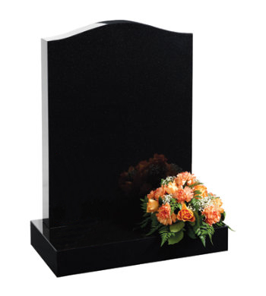 | 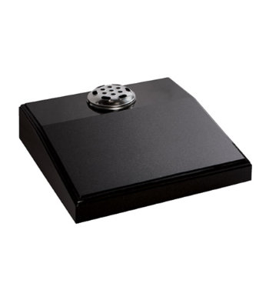 | 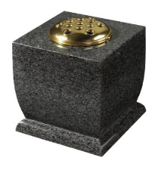

Type and colour of stone:
Details of fittings

Type of decorative features if any:(eg painting, photograph, ceramic posy)
Size: Please give full dimensions of proposed memorial
Proposed Inscription: Please use additional paper if necessary

I/we confirm that:

- The memorial will be manufactured and erected to the current minimum BRAMM/NAMM standards and headstones will include an approved anchor system
- I/we agree to be responsible for any damage caused to Parish Council property or to surrounding memorials, tuft etc caused by the negligence of myself, my team and/or any subcontractor employed by me
- I/we agree to remove all unused materials/rubbish and to leave the area in a neat and tidy state
- I/we have explained to the registered owner of the grave space that the memorial remains their property and that they are responsible for keeping it in a good and safe condition to current industry and general Health and Safety standards at all times
- I/we have advised the owner to consider insuring the memorial against accidental damage and vandalism
- I/we enclose a sketch/photograph of proposed memorial

Signed: | Date:
Name of company: | Address of company:

