
Cannington Parish Council

pe

Finance and Staffing Committee

Meeting to be held at 7.30pm on Monday 30th November 2020
via Zoom

AGENDA

.

01/12/20 Apologies for Absence
02/12/20 Declarations of Members Interests

03/12/20 Minutes of the meeting held on 4th December 2019

04/12/20 Matters Arising

05/12/20 STAFFING

06/12/20 FINANCE

- To review budget and produce forecast for 20/21
- Budget provisions and Precept for 2021/22
- Review Capital works

07/12/20 Items for the next meeting

08/12/20 Date and Time of next meeting

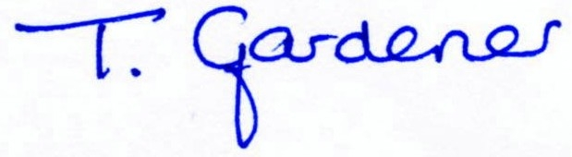

Tina Gardener Clerk to the Parish Council – 25th November 2020

