

Please complete the various sections of the form below as appropriate and return to the Head of Development Services.

Name of Parish/Town Council | CANNINGTON PARISH COUNCIL
Application Reference | 13/18/00040/DD
Location | Land to the North of Grange Farm, Main Road, Cannington

 |  | Tick if appropriate
This Council has no observations to offer.
This Council supports this proposal on the following valid  planning grounds: - |  | ✓
- The emerging SDC Local Plan states that Cannington, as a Tier 2 settlement, has to accommodate an additional 163 dwellings within the plan period. This allocation would substantially comply, in part, with that requirement.
- The site is immediately adjacent to the Village Development Boundary and a residential estate of a similar density. It’s development, also for residential purposes, does not involve raised or elevated land, the loss of trees or areas which is unduly prominent in the landscape. The proposal therefore would comply with the policies of the draft Cannington Neighbourhood Plan.
- The proposal includes 30% affordable housing (22 units) as an integral part of the development.
- The site has ease of access from the main A39 roundabout and the works can be accommodated without disruption to the village road network, or access to existing homes.
- The development of the site, to the east of the roundabout, will not impinge nor obstruct the forthcoming Traffic Calming Scheme in 2019.
- It is considered that any adverse potential impacts can be overcome by the imposition Planning Conditions. The support of the parish council is dependant on all these safeguarding conditions being applied to the decision notice. Also, that Sedgemoor District Council ensures that the development is only carried out in strict accordance with these required provisions:
- No more than 73 dwellings are to be permitted on the site.
- No buildings shall exceed two storeys in height.
- All dwellings shall have a minimum of two designated parking spaces.
- No new windows shall be included within 21 metres of an existing dwelling.
- No boundary trees at the rear of the site, or on adjoining land, shall be felled or adversely affected.
- With the exception of that small part necessary to accommodate essential highway works, the hedgerow at the front of the site shall be retained, protected and maintained as an integral part of the development. Replacement landscaping in the form of roadside trees shall be planted fronting the roundabout.
- The area of proposed bunding along the southern boundary shall be comprehensively landscaped with trees and shrubs.
- The access road shall include a standard specification footway/cycleway along the entire length of the spine road. The width of the cycleway adjoining the roundabout shall be increased in size to match that of the recently constructed cycleway to the Sandford Roundabout.
- Provision should be made off site for improved bus shelters along Main Road as part of the approved highway works.
- A children’s public play space shall be informed in the central location shown on the plans, and provided and offered for adoption prior to the completion of the 40th dwelling.
- The Affordable Housing must be agreed in consultation with the parish council, prior to granting consent and must be only available to residents of Cannington Parish. This must be provided in full, prior to the completion of 40 dwellings on site.
If our observations coincide with those of Claire Pearce, Group Manager, in accordance with the delegation scheme, we accept that the application will not be reported to the Development Control Committee unless one of the other exceptions in the delegation scheme apply. | ✓

Signed: Date: 20/11/18
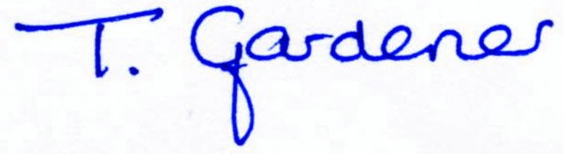
Tina Gardener
Clerk to Cannington Parish Council

For Internal Use Only
Full Committee: Date:
Members Notification Sent by email Date: n/a
Ratified by Full Parish Council Date:
E-mail to SDC: Date: ……………

FOR FILING

