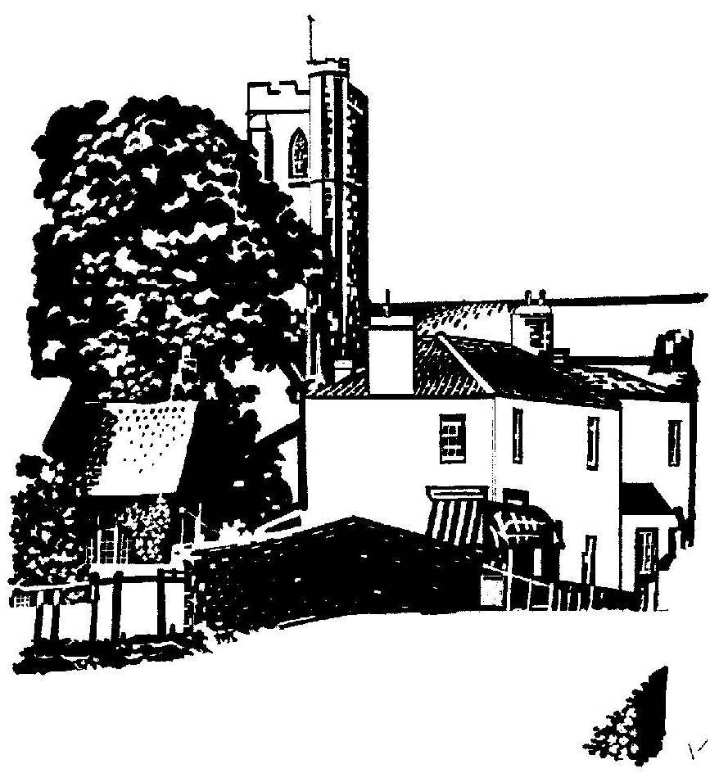
Cannington Parish Council

pe

The Annual Parish meeting
will take place at 7.00pm on Monday 21st May 2018 in Cannington Village Hall

AGENDA

- Welcome
- Nic Wall – Presentation on the renovation of the Packhorse Bridge
- Apologies for Absence
- Minutes of the meeting held on 22nd May 2017
- Annual report from the Chairman of the Parish Council
- Presentation of the Child of Cannington Award
- Reports from village groups

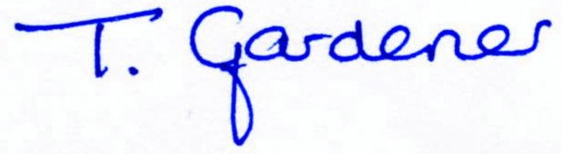

Clerk to Cannington Parish Council

