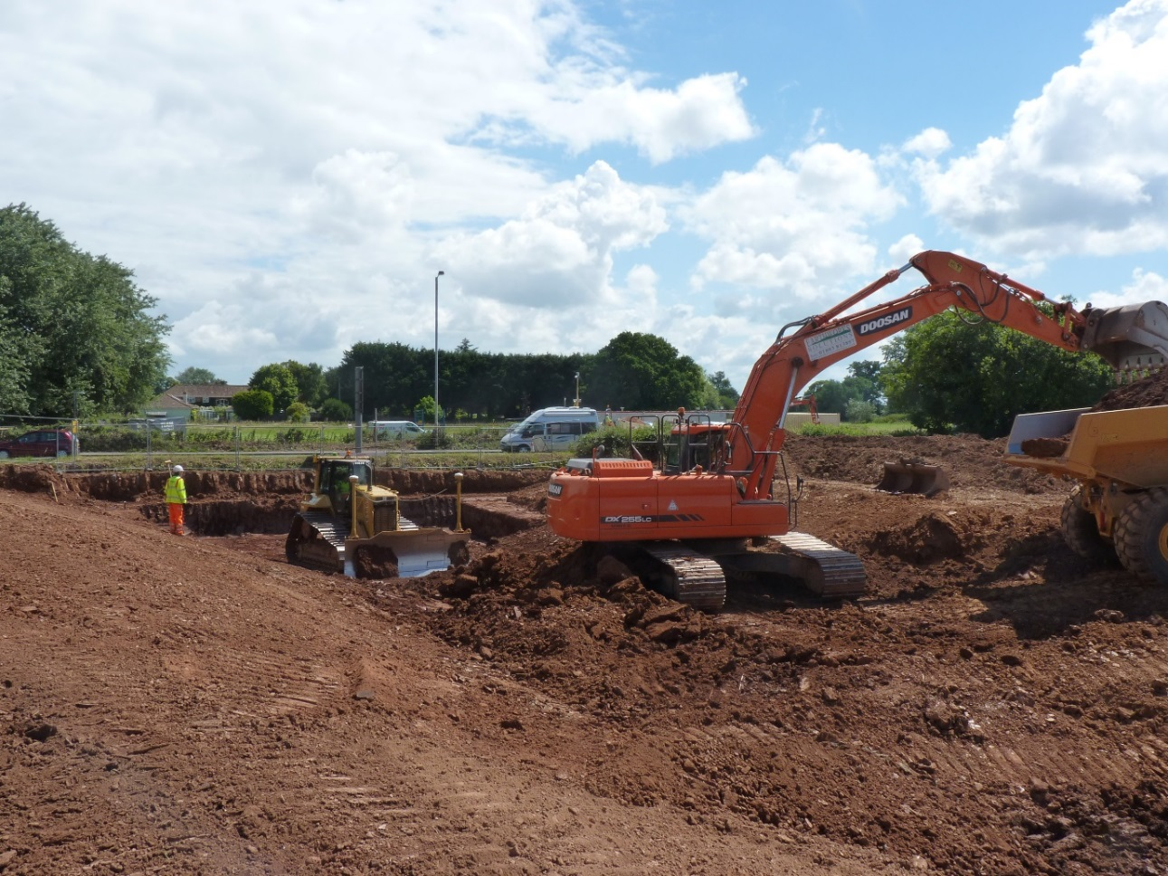
Looking at upstream flood channel approach to A39 culverts (to be installed)
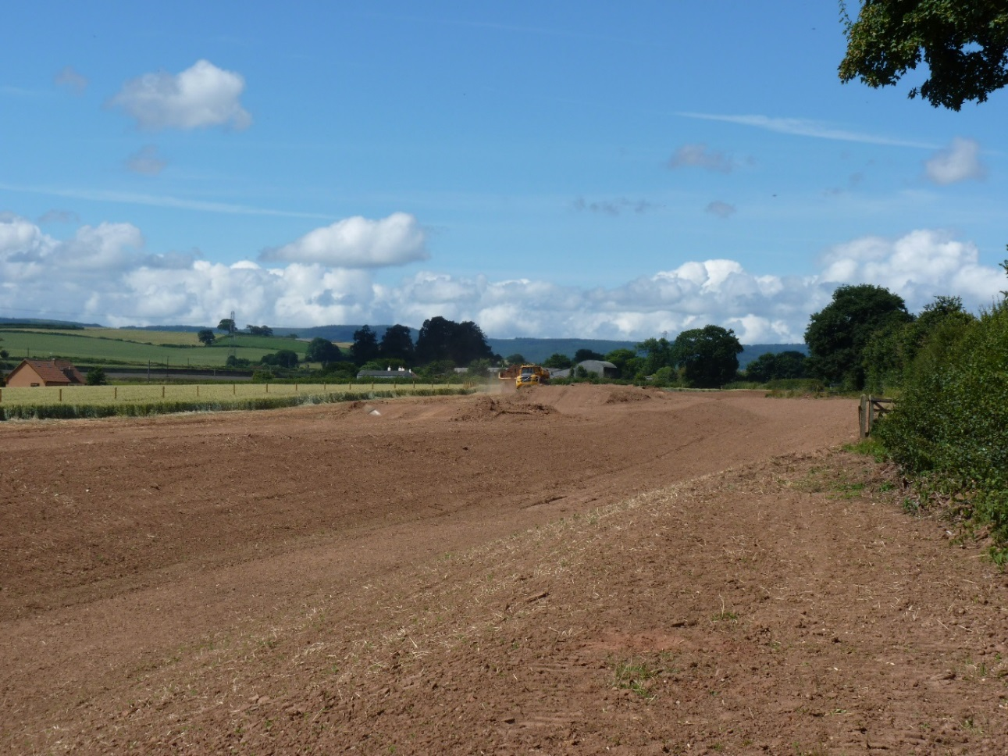
Looking west (upstream) on new flood channel from near A39 – yet to be seeded
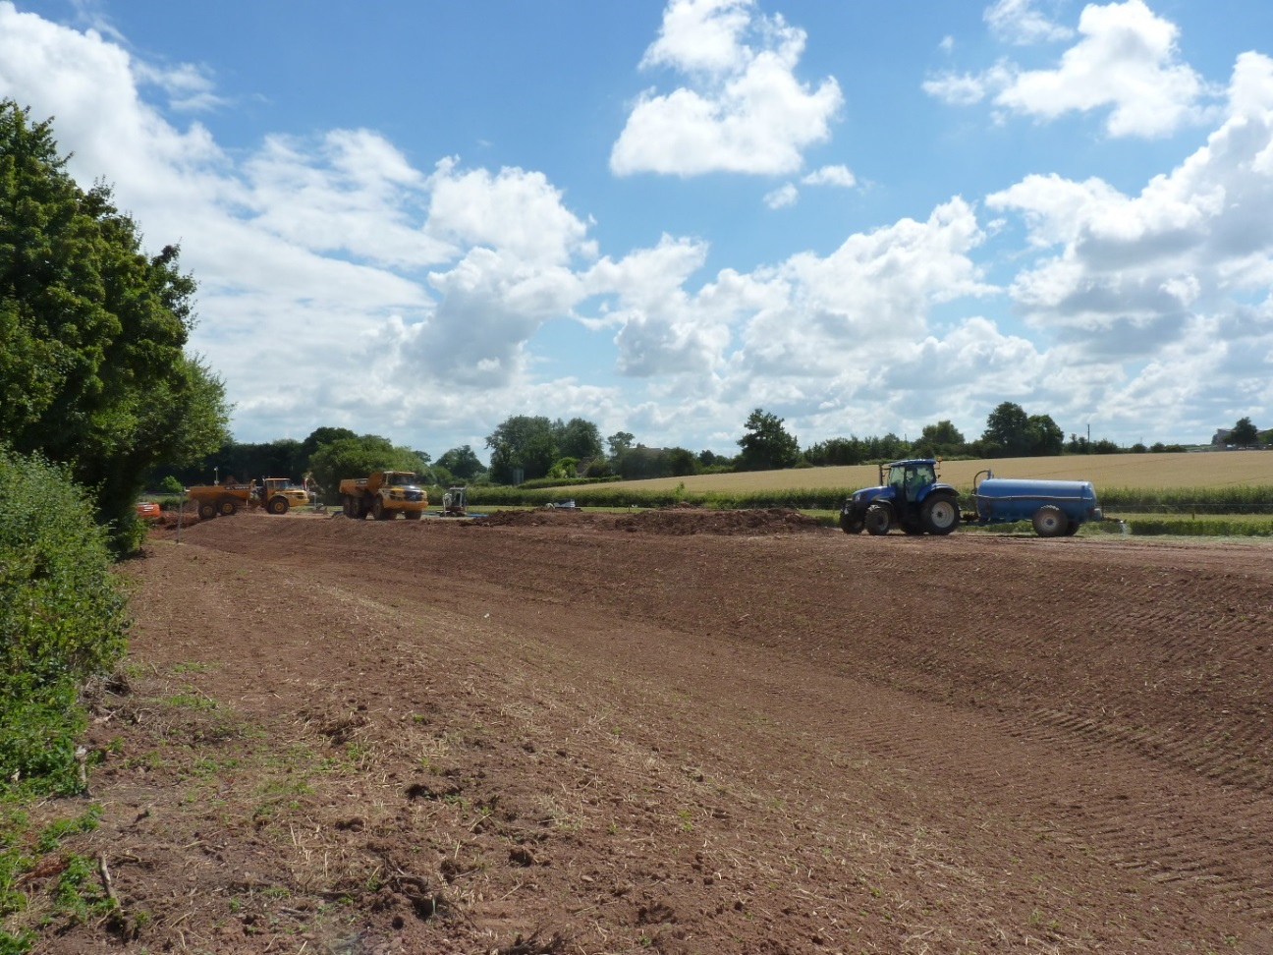
Looking downstream on new flood channel towards the A39 under crossing
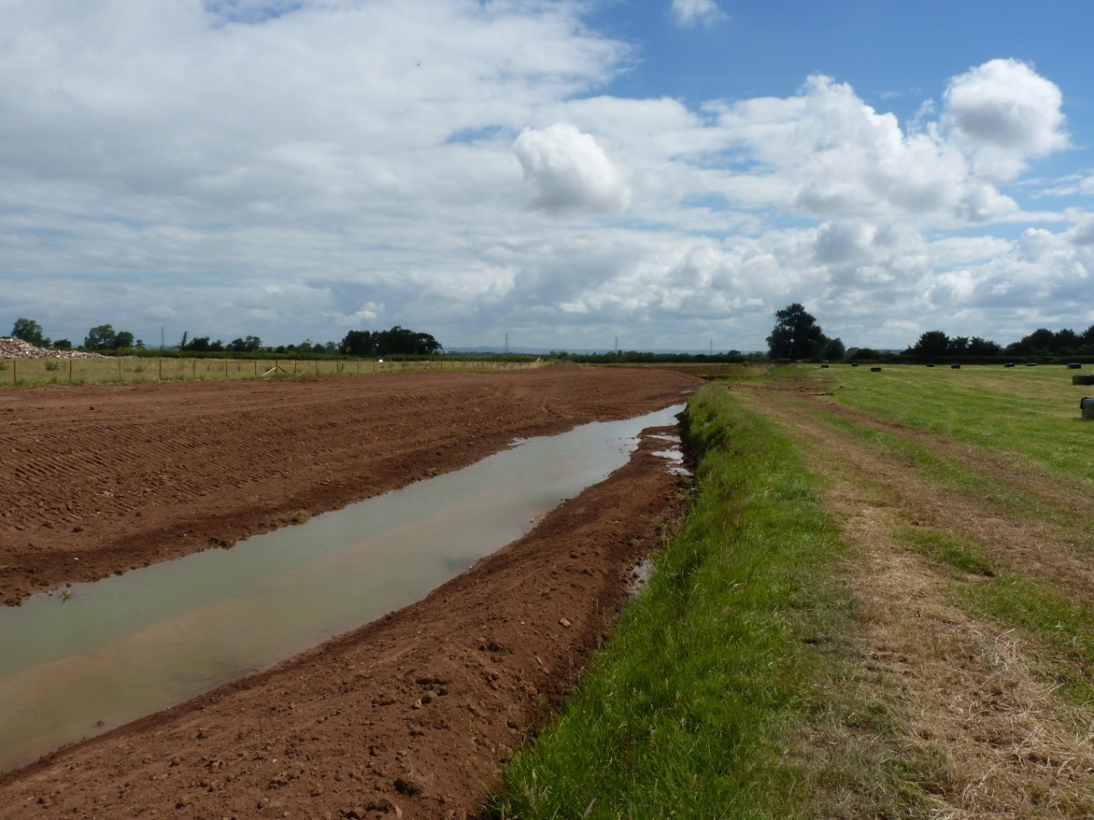
Looking downstream on new enlarged flood channel towards confluence with original brook course.
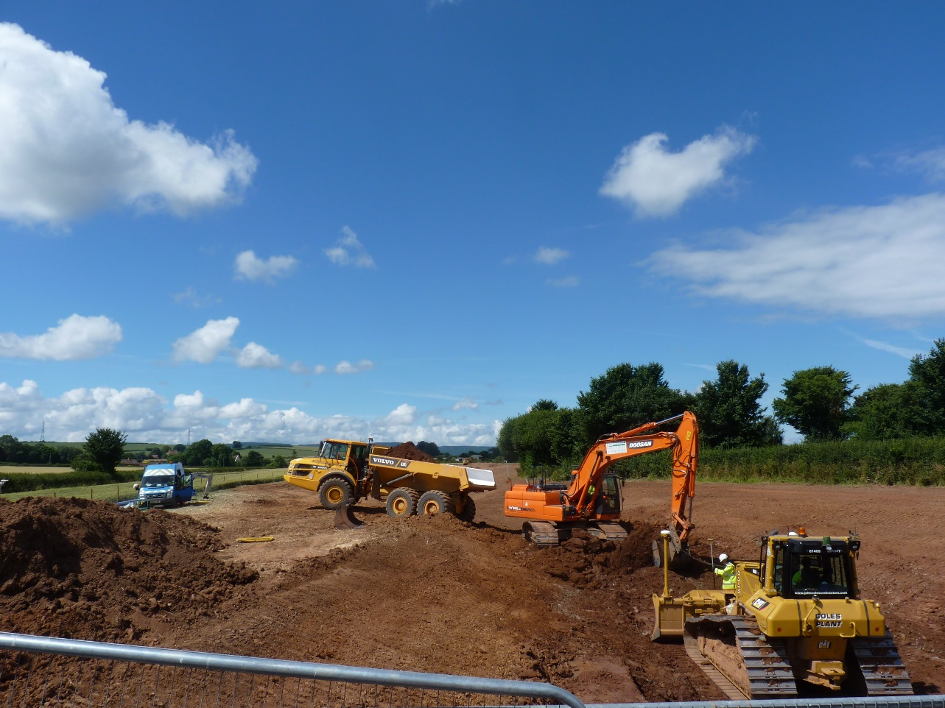
Looking upstream (west) from A39 along new flood channel – Wessex Water pipe welding crew getting ready for water main diversion to far left of shot.
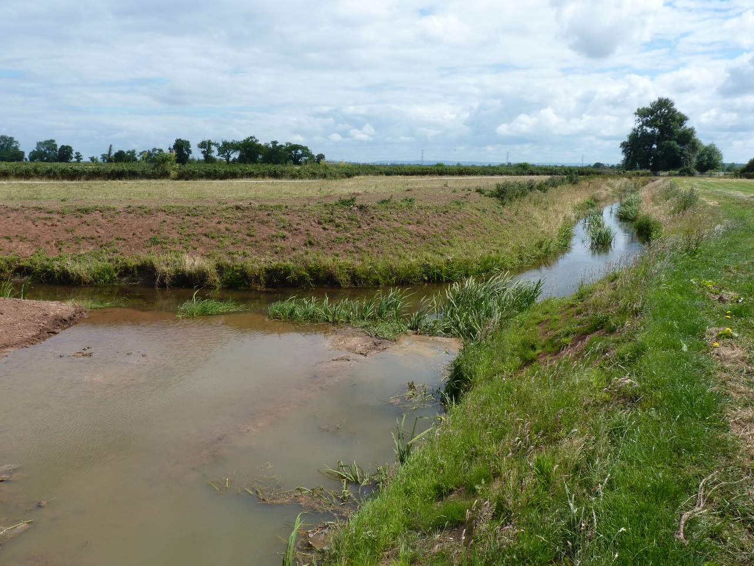
Downstream end of scheme where new channel (foreground) re-joins Cannington Brook

