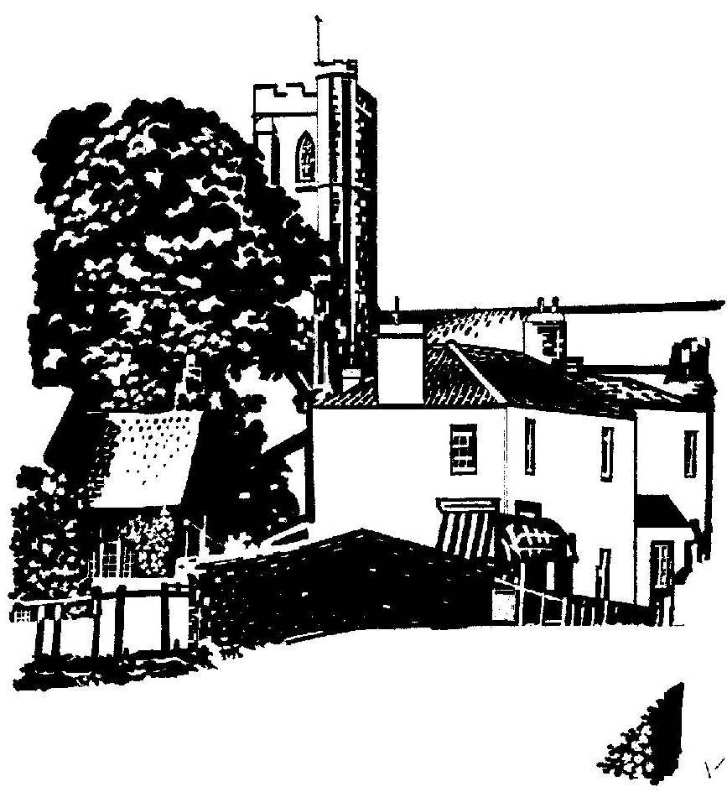
Cannington Parish Council

pe

The Annual Parish meeting
will take place at 7.00pm on Tuesday 22nd May 2017 in Cannington Village Hall

AGENDA

- Welcome
- Apologies for Absence
- Minutes of the meeting held on 24th May 2016
- Annual report from the Chairman of the Parish Council
- Presentation of the Child of Cannington Award
- Reports from village groups

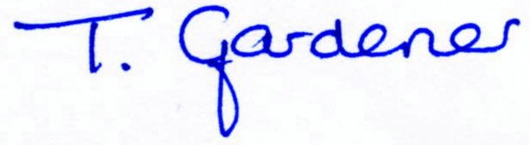

Clerk to Cannington Parish Council

