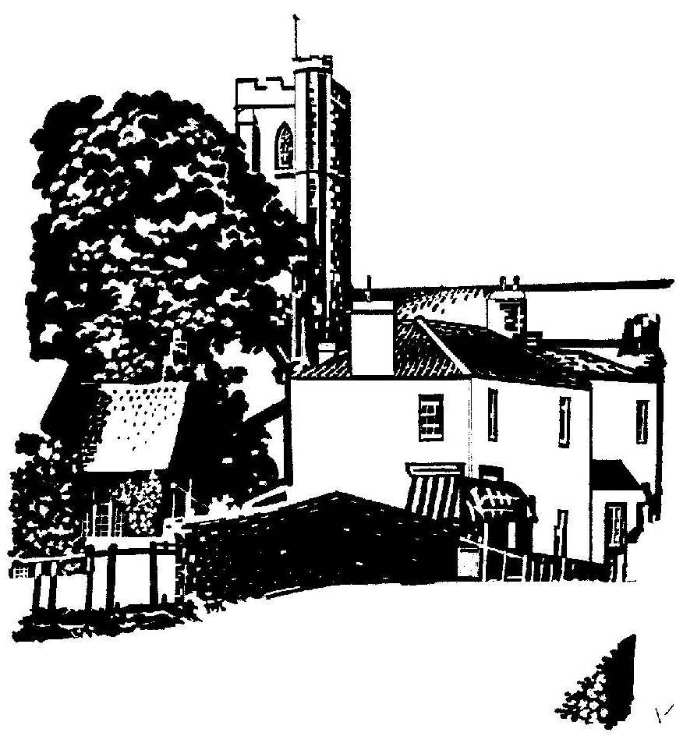
Cannington Parish Council

pe

The Annual Parish meeting
will take place at 7.00pm on Monday 22nd May 2017 in Cannington Village Hall

AGENDA

- Welcome

1a Environment Agency – Meri Fernandez and Matt Phillips

1b EDF – Stuart McLoughlin (Project Manager, Cannington Park and Ride)
- Apologies for Absence
- Minutes of the meeting held on 24th May 2016
- Annual report from the Chairman of the Parish Council
- Presentation of the Child of Cannington Award
- Reports from village groups

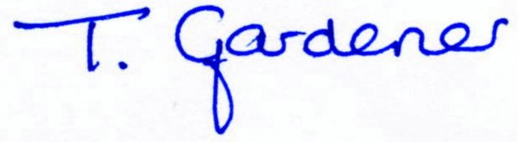

Clerk to Cannington Parish Council

